In this user guide we will demonstrate how to create a bookmark in a Samsung Android Device.
- Open a browser on the Samsung Android Device.

- Type in the URL address. Click Go.
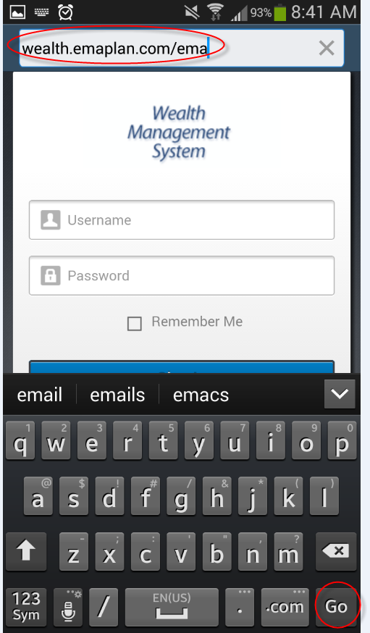

Please Note:
To find the URL, please reference the email your Advisor sent to you. If you are not sure what the URL address is, please contact your Advisor. The link should look something like this example:
https://wealth.emaplan.com/ema/brokerdealer/companyname

- Choose Bookmarks. Click the “+” (plus) sign. Rename the bookmark as desired, then click SAVE.
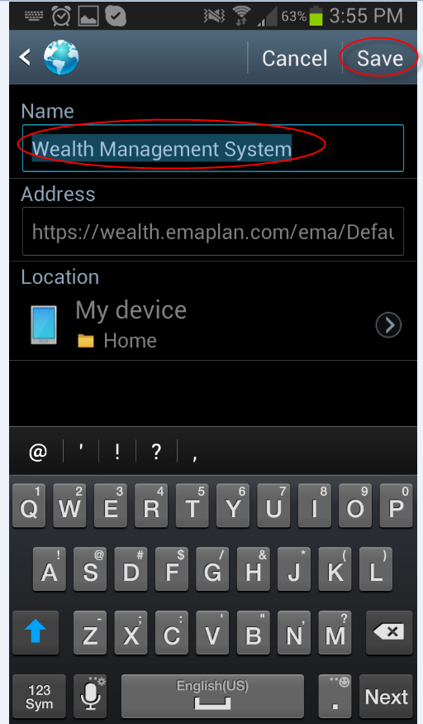
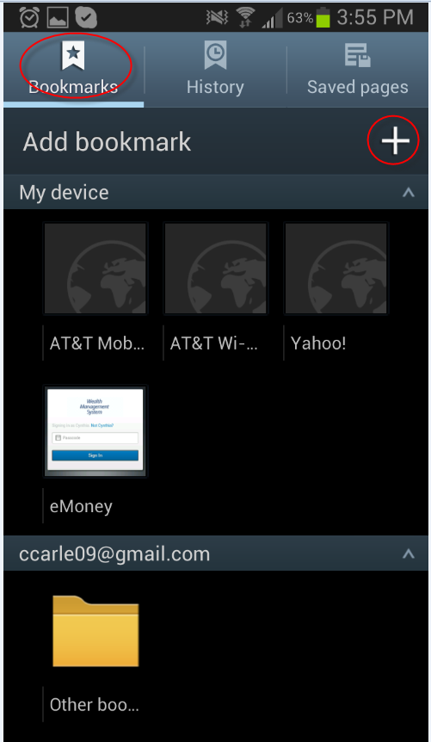

- A bookmarked icon of this page will now appear under the “My Device” category. Press and hold this icon until a menu appears.

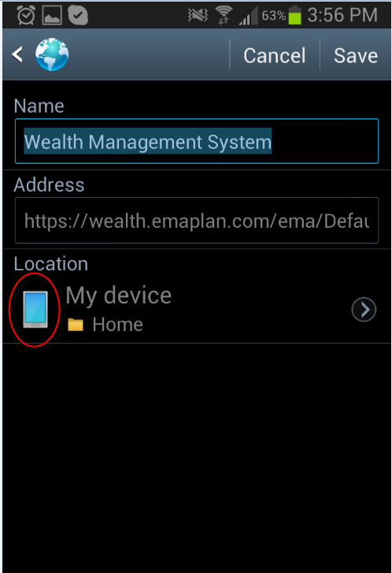
- The icon logo should now appear on the home page.
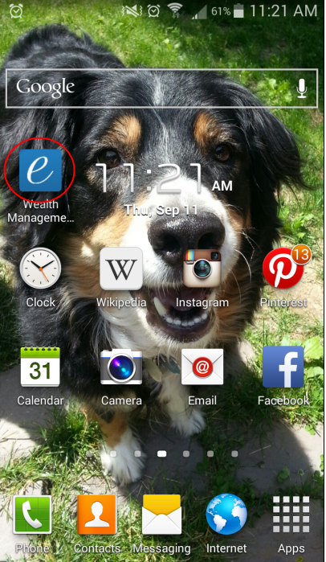

- Select “Add shortcut to home screen.”
