In this training guide we will demonstrate how to upload to the vault from a mobile device.

Requirements:
This functionality is currently limited to iOS devices running iOS 6 and 7 on
Functionality on Androids may vary – it may or may not work depending on the version. Uploading to the Vault is not officially supported on Android.
Contact your advisor if you have any difficulty.
[ADVISOR NAME]
[PHONE NUMBER]

- After signing into the mobile site, select Vault.

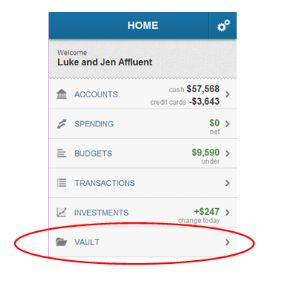

- To add a new file or folder, click on the Shared Documents folder and then on the + sign.

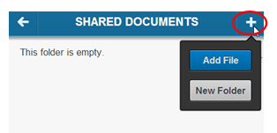

- When adding a new folder, selecting Done will create the new folder. Cancel will return to the previous screen.

- When Add File is selected, you will be given the option to take a photo or upload one from the photo library straight into the vault. Rename the file if needed.
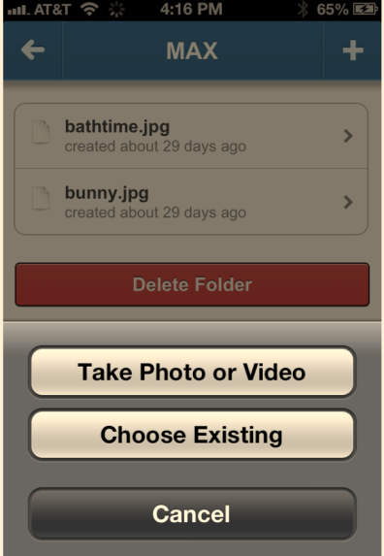

- To Delete a file, select the document and the delete button will be available at the bottom.

