Charitable Remainder Trust Analysis
Recommended Plan
Prepared for Jerry and Ruth Stein
The Charitable Remainder Trust (CRT) Analysis report illustrates the projected value of trust assets over time. A Charitable Remainder Trust is an agreement between you and a trustee to hold assets for a term. The term may be for the lifetime of you, your spouse and/or other beneficiaries or for a set period of time not to exceed 20 years. The income beneficiaries receive income for the life of the trust, and at the end of the term, the remainder of the trust is distributed to the charitable beneficiaries.
50% of Company Stock to Charit Trust
Start Date: |  | 1/1/2019
Grantor: |  | Jerry and Ruth (Joint/ROS)
Term Based on the Life of: |  | Jerry and Ruth Stein
Cash Payment Type: |  | Unitrust
Payment Rate: |  | 7.0%
IRC Rate: |  | 2.0%

Year | Age | Beginning  of Year  Balance | Transfers  In | Growth and  Income | Total  Distributions | End of  Year  Balance
2019 | 70/69 | $0 | $3,412,280 | $301,646 | $238,860 | $3,475,066
2020 | 71/70 | 3,475,066 | 0 | 307,196 | 243,255 | 3,539,007
2021 | 72/71 | 3,539,007 | 0 | 312,848 | 247,730 | 3,604,125
2022 | 73/72 | 3,604,125 | 0 | 318,605 | 252,289 | 3,670,441
2023 | 74/73 | 3,670,441 | 0 | 324,467 | 256,931 | 3,737,977
2024 | 75/74 | 3,737,977 | 0 | 330,437 | 261,658 | 3,806,756
2025 | 76/75 | 3,806,756 | 0 | 336,517 | 266,473 | 3,876,800
2026 | 77/76 | 3,876,800 | 0 | 342,709 | 271,376 | 3,948,133
2027 | 78/77 | 3,948,133 | 0 | 349,015 | 276,369 | 4,020,779
2028 | 79/78 | 4,020,779 | 0 | 355,436 | 281,455 | 4,094,760
2029 | 80/79 | 4,094,760 | 0 | 361,977 | 286,633 | 4,170,104
2030 | 81/80 | 4,170,104 | 0 | 368,637 | 291,907 | 4,246,834
2031 | 82/81 | 4,246,834 | 0 | 375,420 | 297,278 | 4,324,976
2032 | 83/82 | 4,324,976 | 0 | 382,328 | 302,748 | 4,404,556
2033 | 84/83 | 4,404,556 | 0 | 389,363 | 308,319 | 4,485,600
2034 | 85/84 | 4,485,600 | 0 | 396,527 | 313,992 | 4,568,135
2035 | 86/85 | 4,568,135 | 0 | 403,824 | 319,769 | 4,652,190
2036 | 87/86 | 4,652,190 | 0 | 411,253 | 325,653 | 4,737,790
2037 | 88/87 | 4,737,790 | 0 | 418,821 | 331,645 | 4,824,966
2038 | 89/88 | 4,824,966 | 0 | 426,527 | 337,748 | 4,913,745
2039 | 90/89 | 4,913,745 | 0 | 434,375 | 343,962 | 5,004,158
2040 | 91/90 | 5,004,158 | 0 | 442,367 | 350,291 | 5,096,234
Totals |  |  | 3,412,280 | 8,090,295 | 6,406,341

Charitable Remainder Trust Analysis
Recommended Plan
Prepared for Jerry and Ruth Stein
The Charitable Remainder Trust (CRT) Analysis report illustrates the projected value of trust assets over time. A Charitable Remainder Trust is an agreement between you and a trustee to hold assets for a term. The term may be for the lifetime of you, your spouse and/or other beneficiaries or for a set period of time not to exceed 20 years. The income beneficiaries receive income for the life of the trust, and at the end of the term, the remainder of the trust is distributed to the charitable beneficiaries.
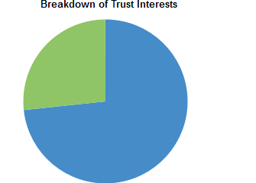
Income Interest ($2,502,498) (73.34%)
Remainder Interest ($909,782) (26.66%)

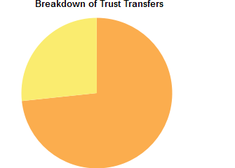
Retained Interest ($2,502,498) (73.34%)
Charitable Deduction ($909,783) (26.66%)

